**MODULE:3.1 (C Language Fundamental)**

1. **Display This Information using printf**

* **Your name**
* **Your birth date**
* **Your age**
* **Your address**

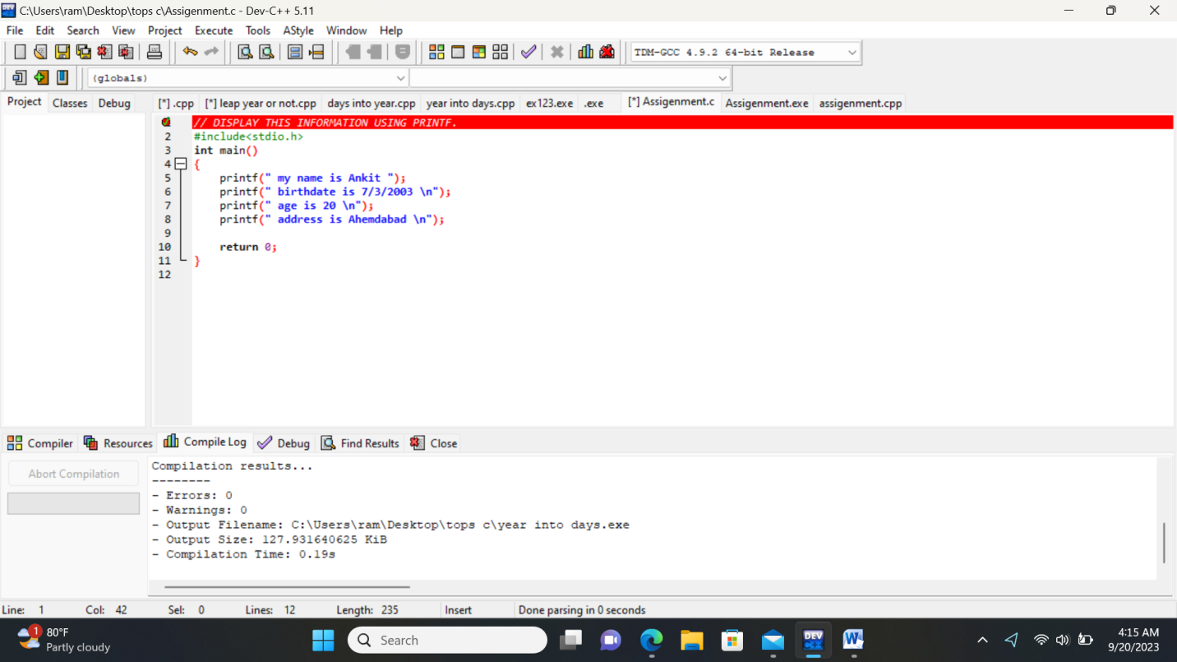

1. **Write a program to make simple calculator.**

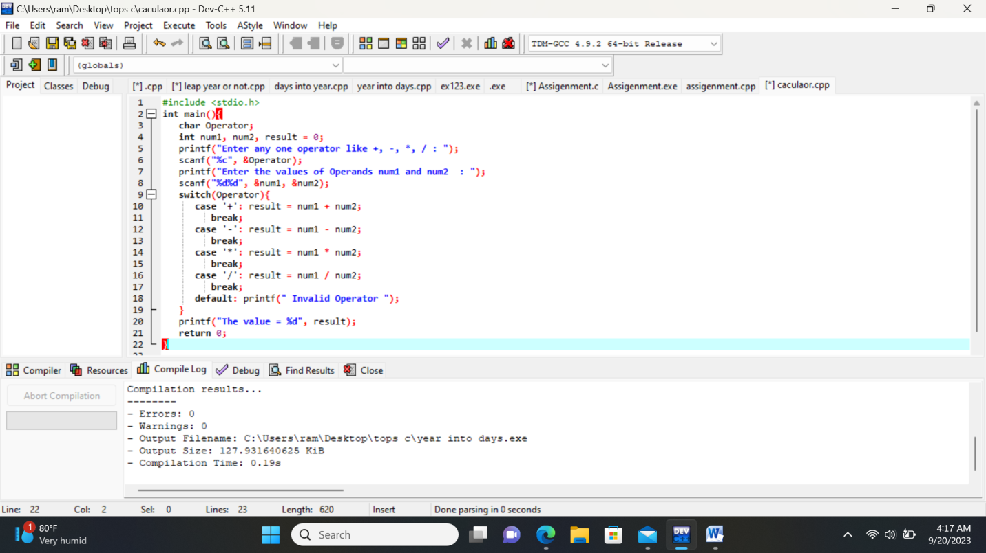

1. **Write a program to find area of circle, rectangle and triangle.**

**Area of circle**

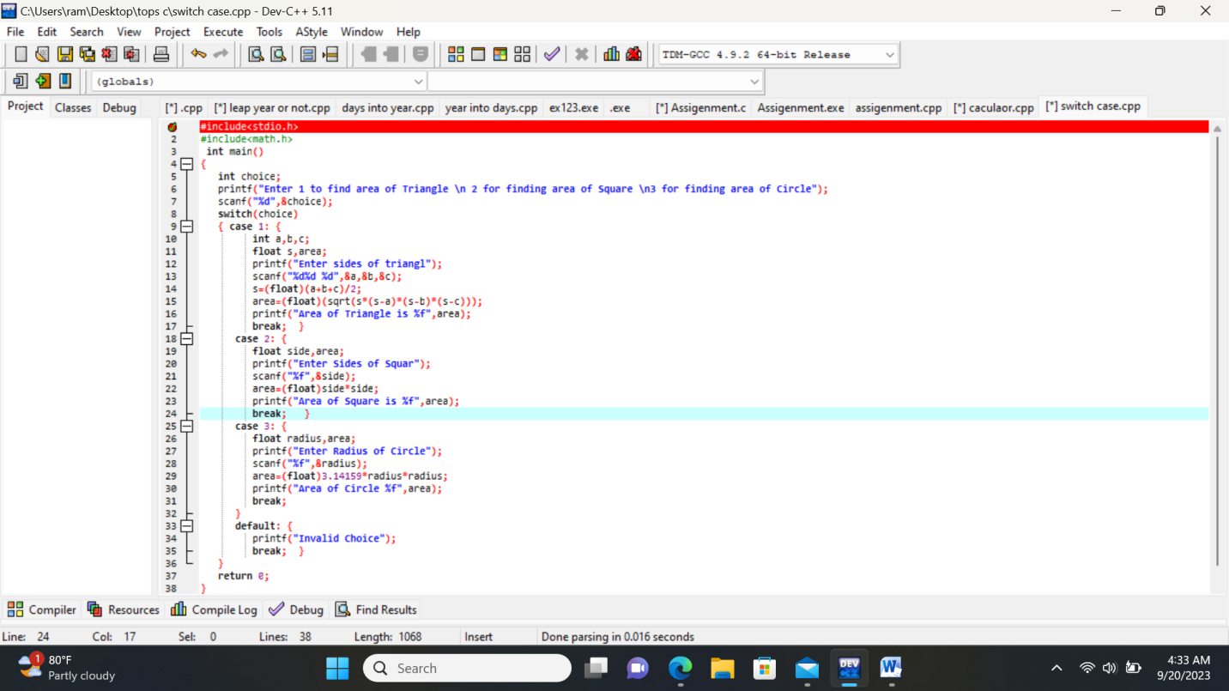

1. **Write a program to find simple interest.**

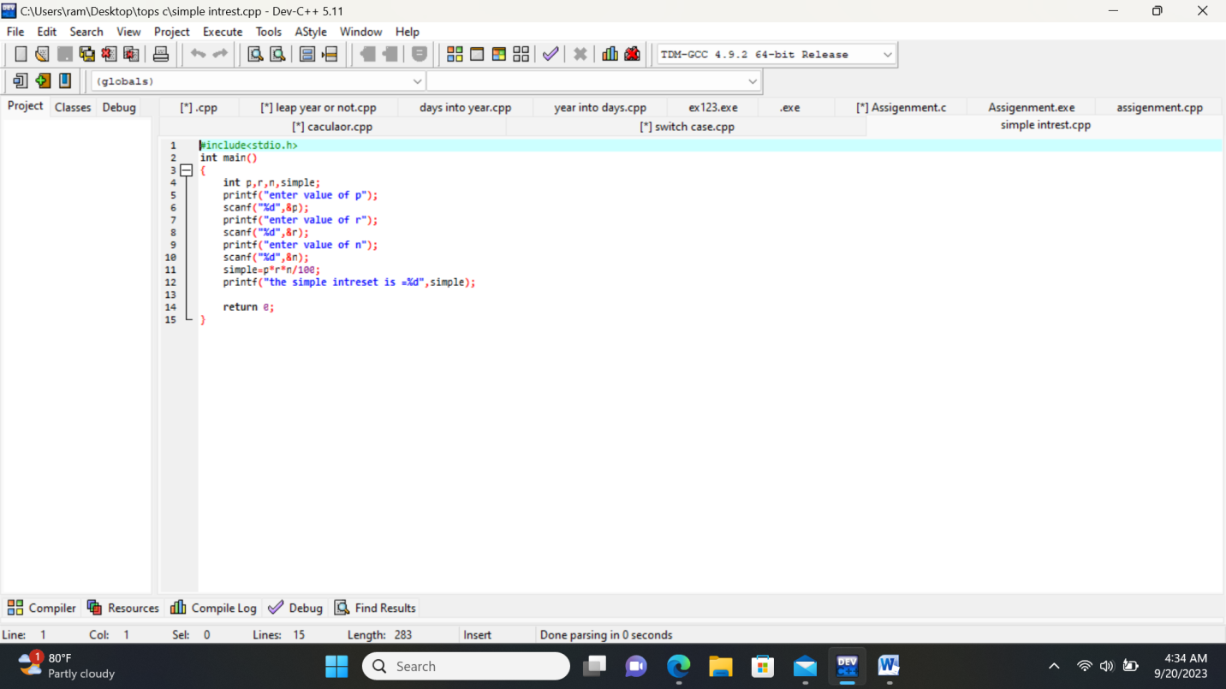

1. **Write a program to check if the given year is leap year or not?**

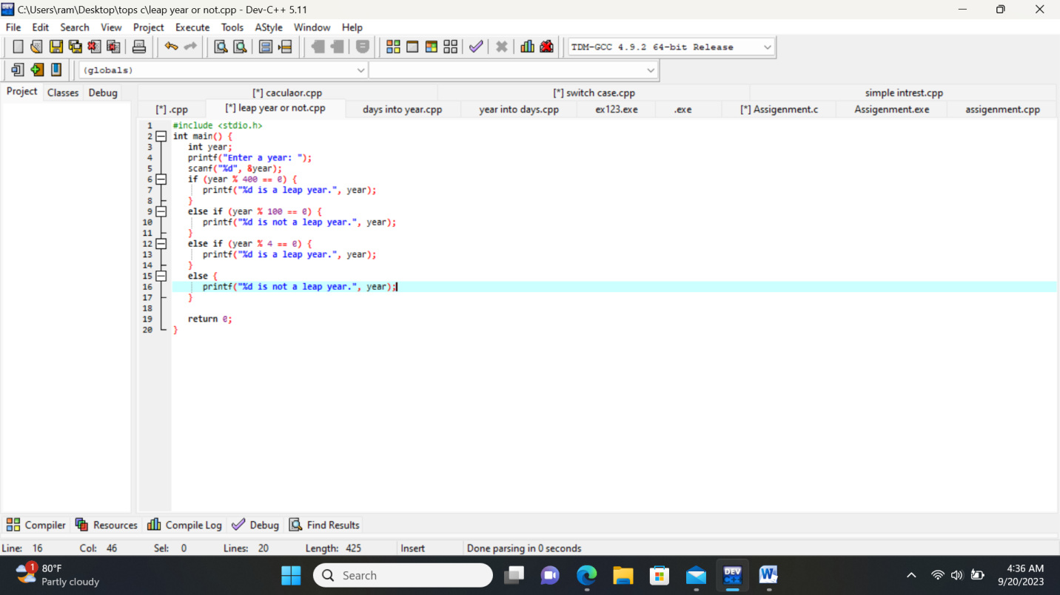

1. **Write a program to converts days into years and years into days.**

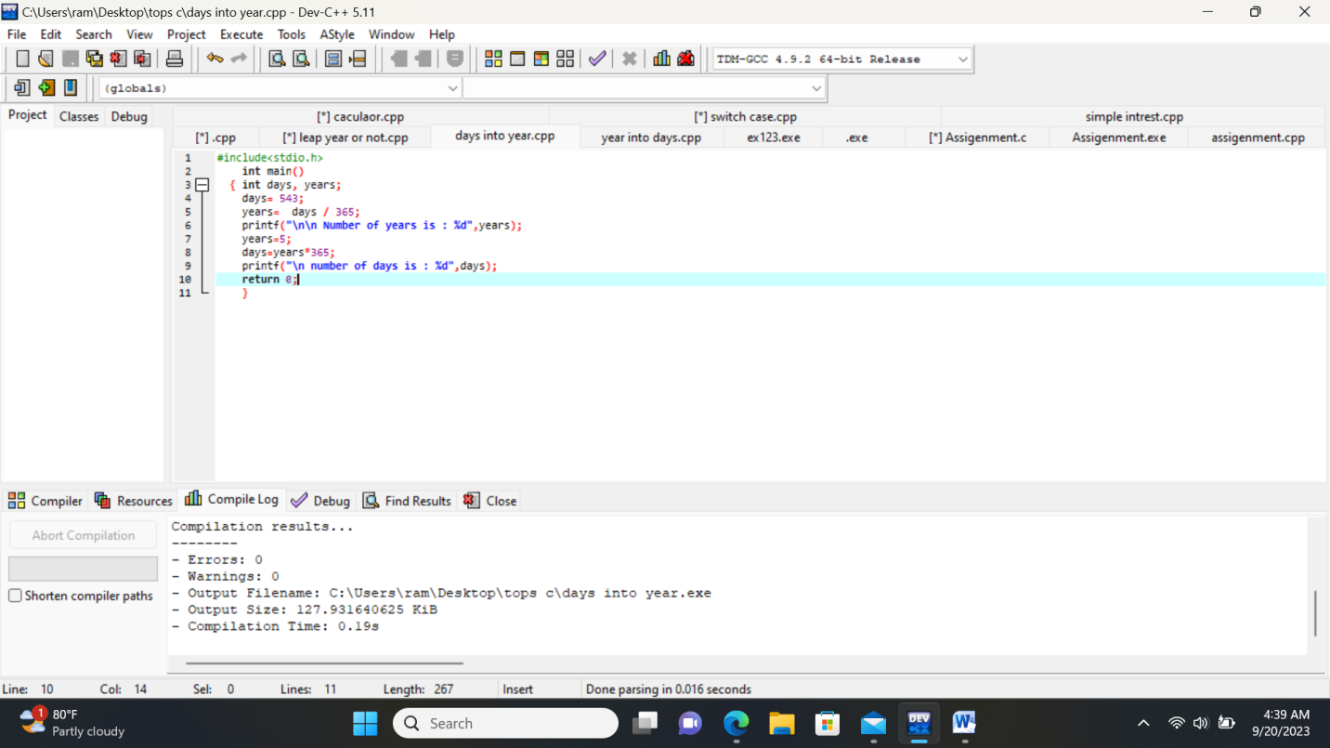

**MODULE: 3.2 (C Language Programing with C)**

• WAP to make simple calculator.

(operation include Addition, Subtraction, Multiplication, Division, modulo)

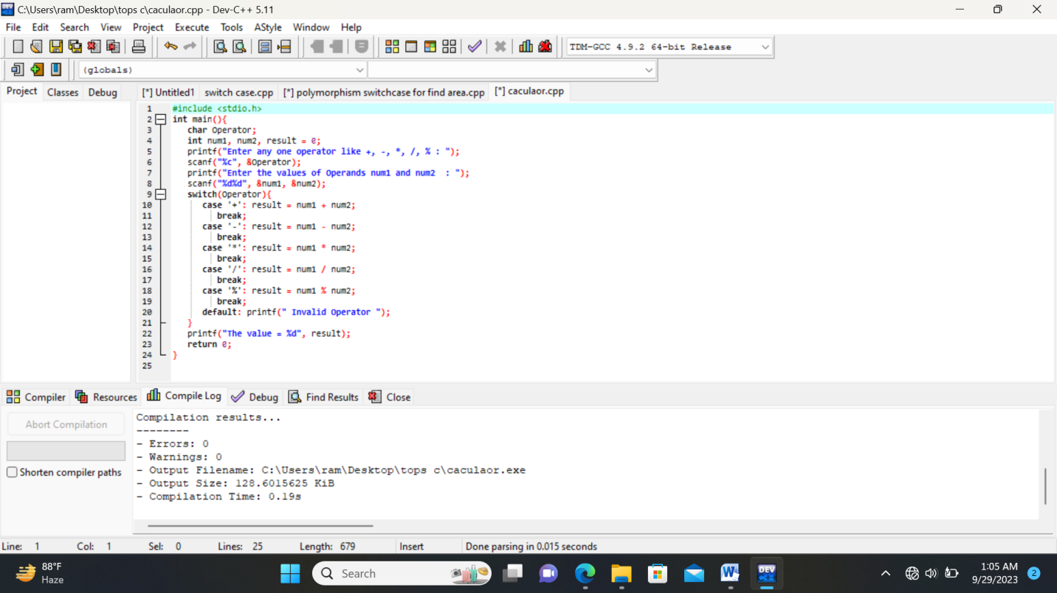

• WAP to swap two numbers without using third variable.

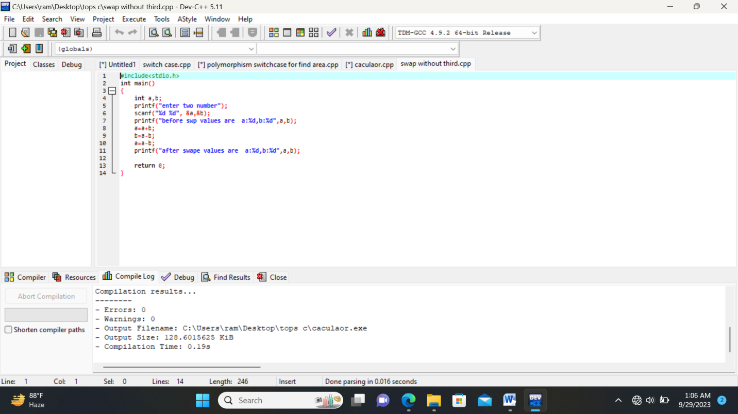

• WAP to find number is even or odd using ternary operator.

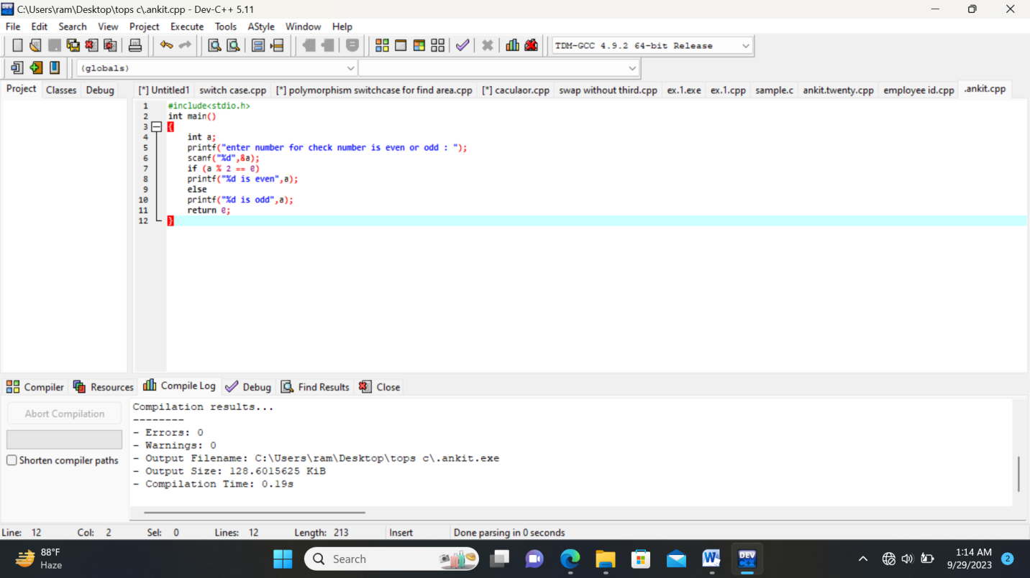

• WAP to show

1. Monday to Sunday using switch case

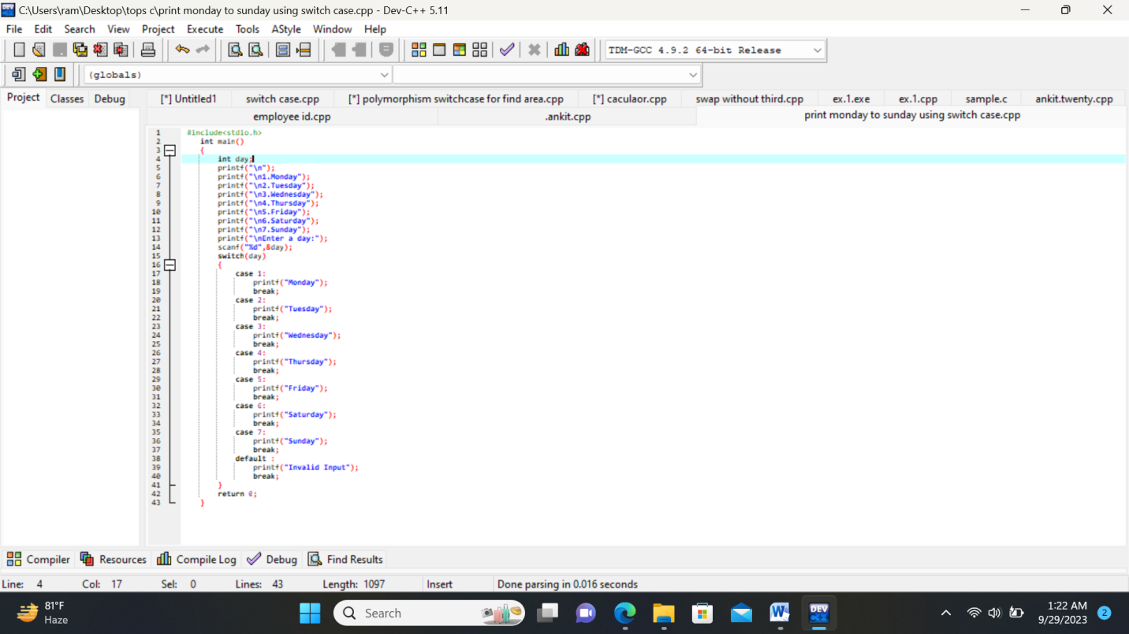

2. Vowel or Consonant using switch case.

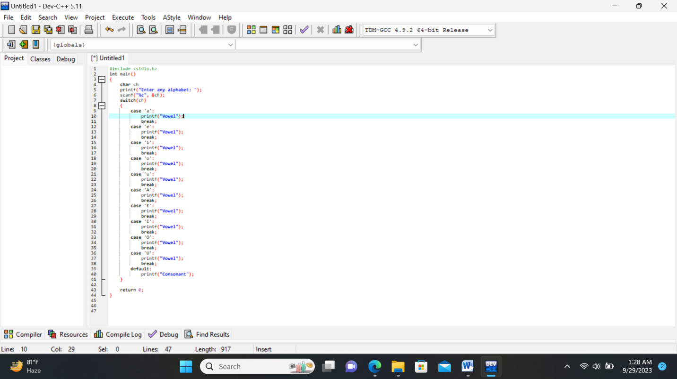

• Looping programs:

1. WAP to print 972 to 897 using for loop.

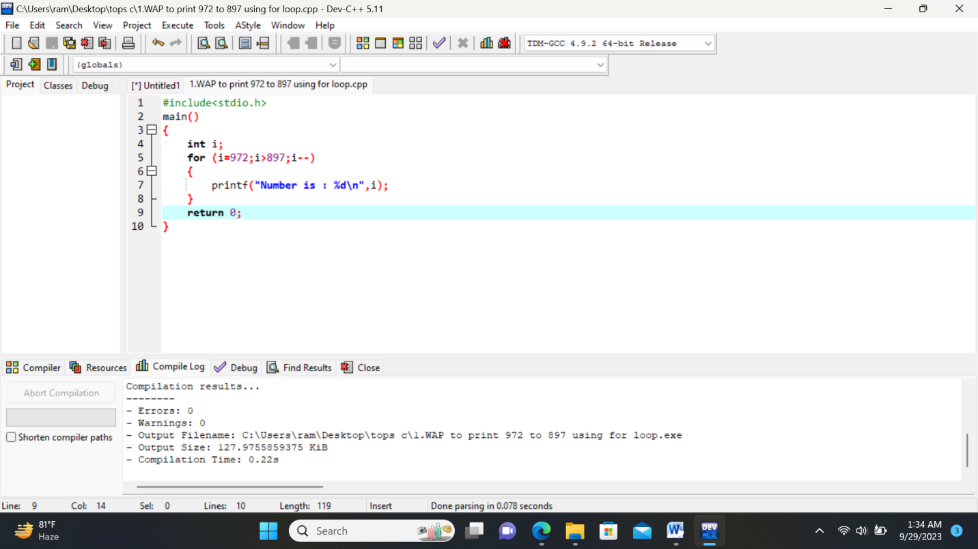

2. WAP to take 10 no. Input from user and find out …

3. How many Even numbers are there

4. How many odd numbers are there

5. Sum of even numbers 6. Sum of odd numbers WAP to print table up to given numbers

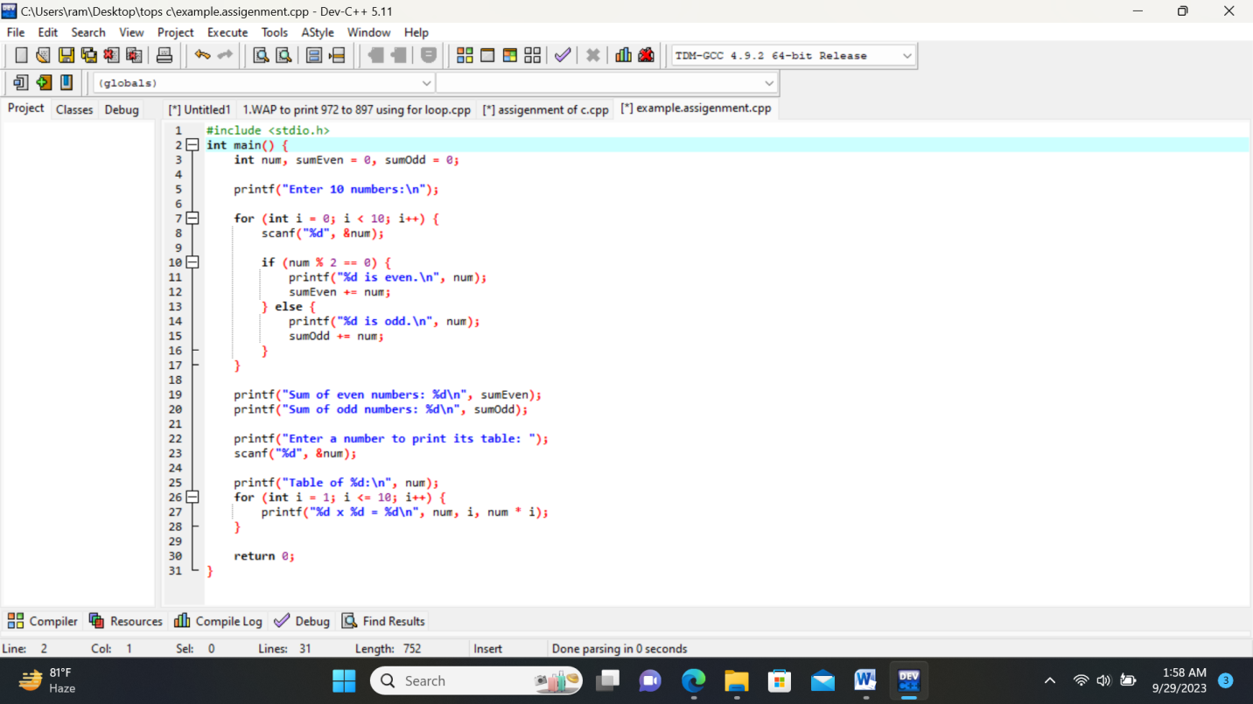

• WAP to print factorial of given number

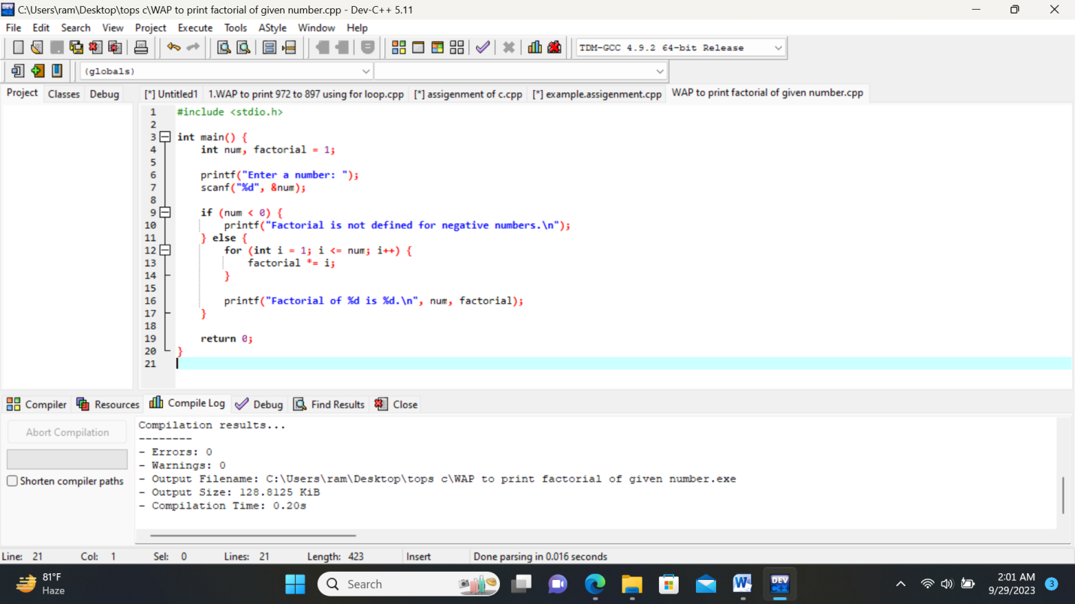

• WAP to print Fibonacci series up to given numbers

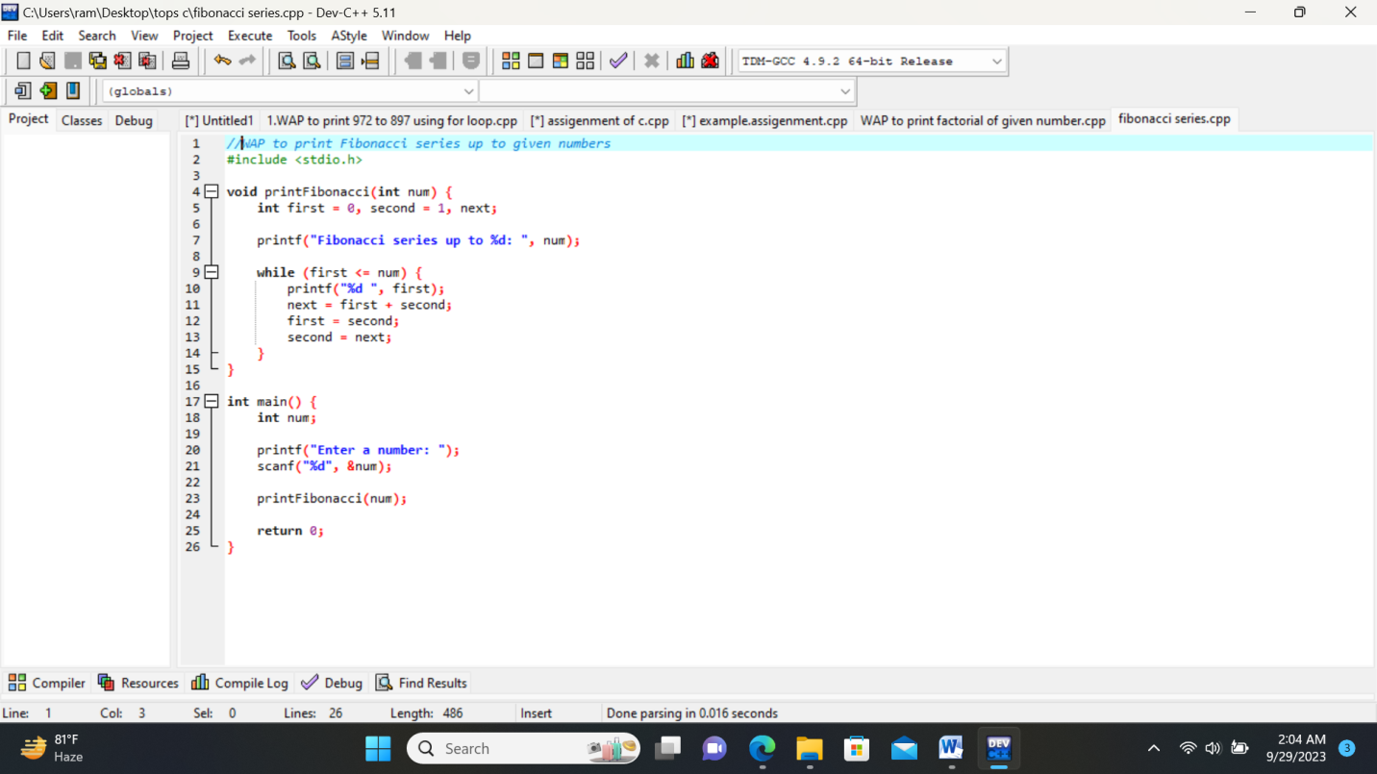

WAP to print number in reverse order e.g.: number = 64728 ---> reverse = 82746.

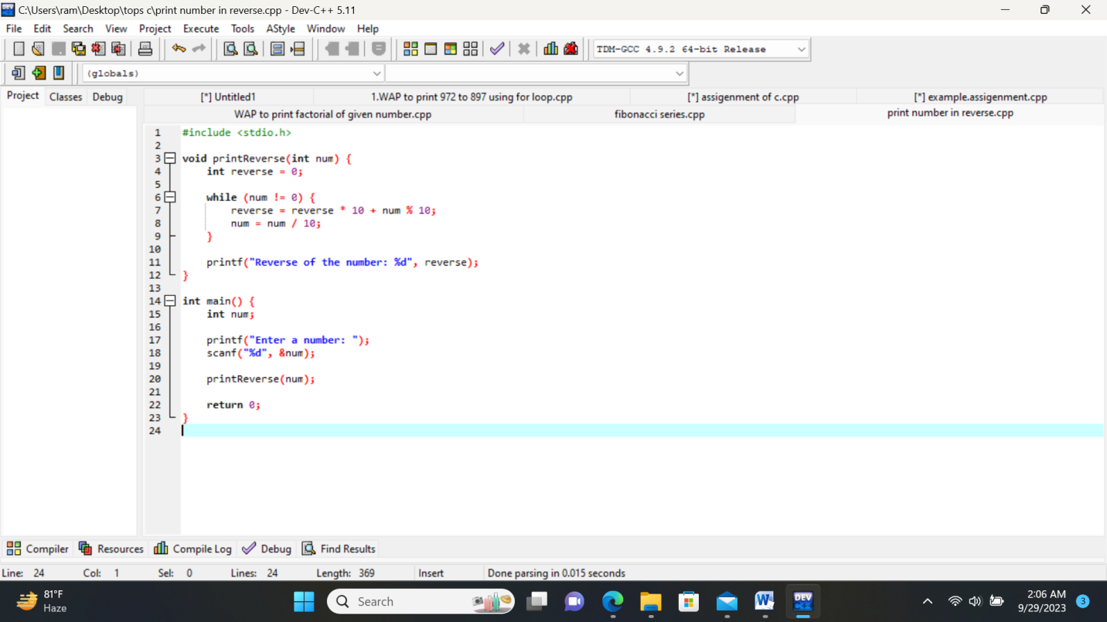

• Write a program to find out the max from given number (E.g., No: -1562 Max number is 6)

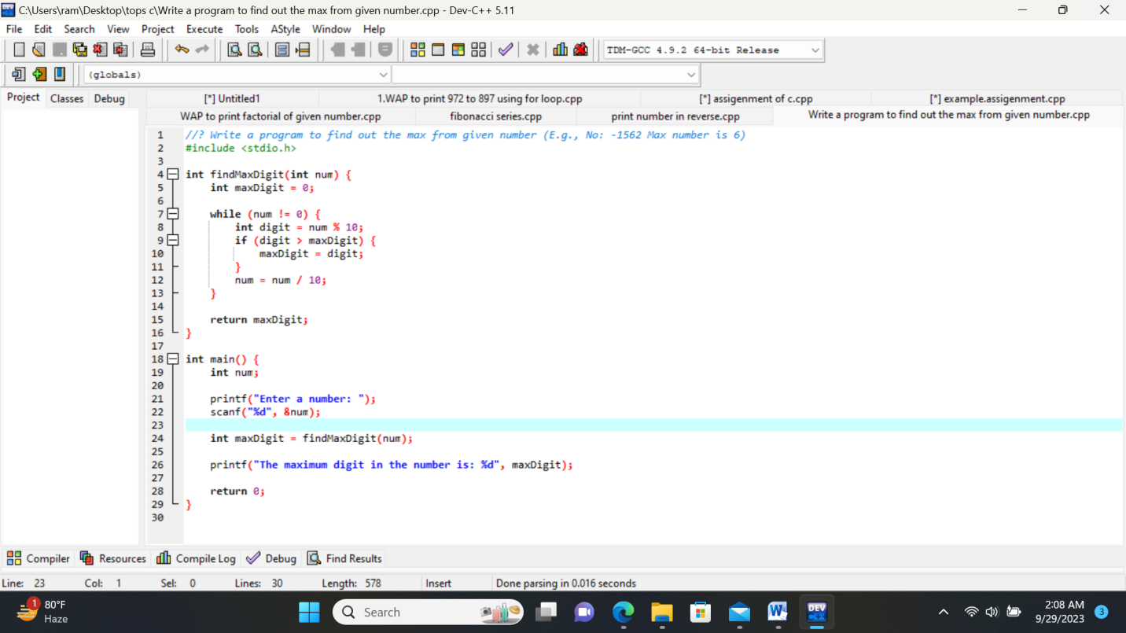

• Write a program make a summation of given number (E.g., 1523 Ans: -11)

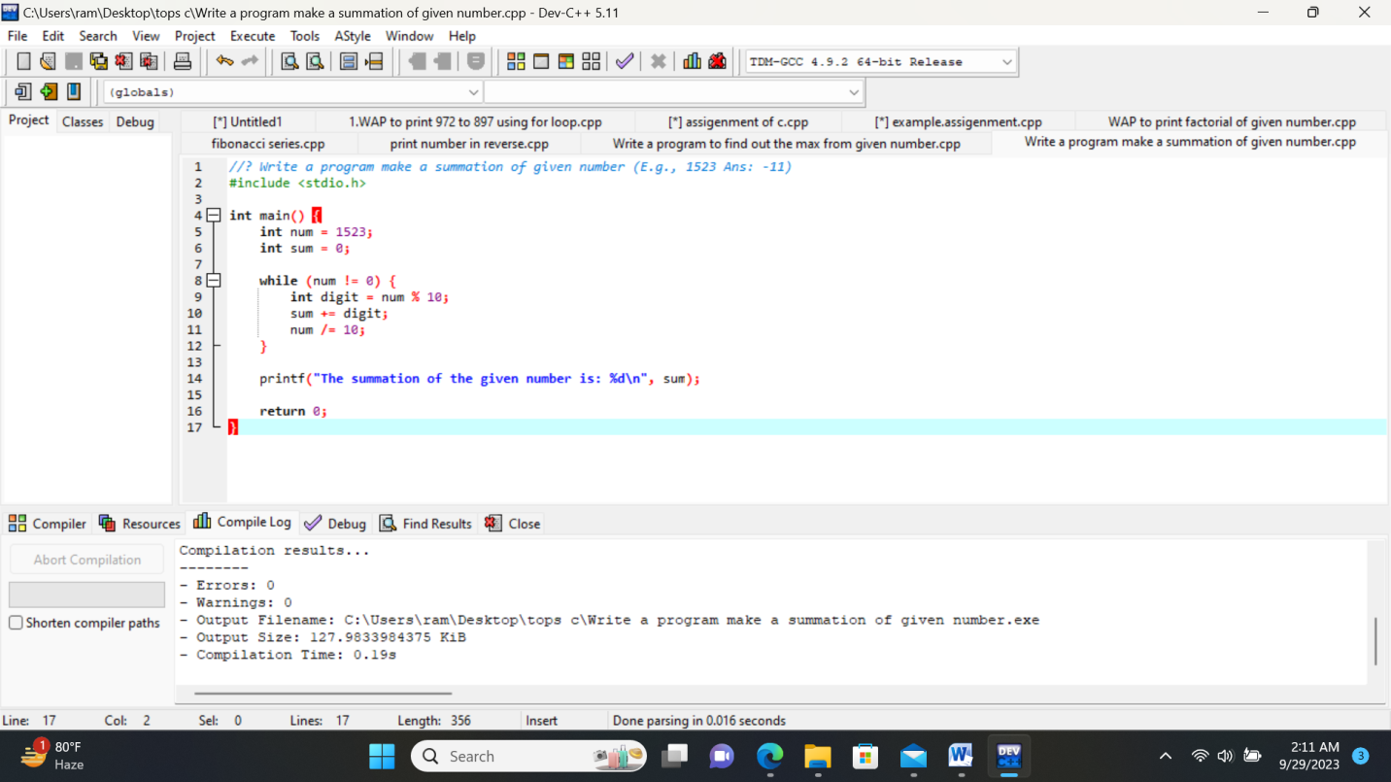

Write a program you have to make a summation of first and last Digit. (E.g., 1234 Ans: -5)

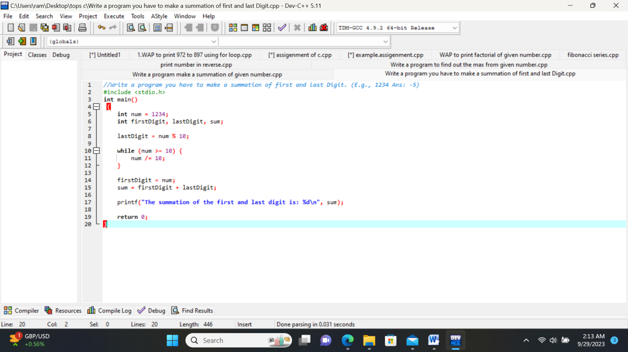

Patterns:

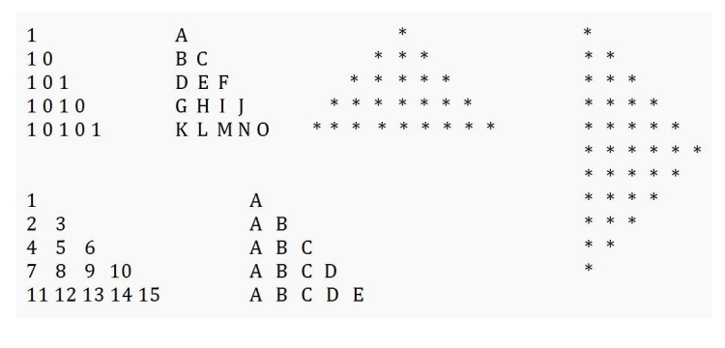

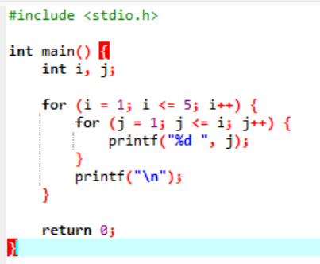

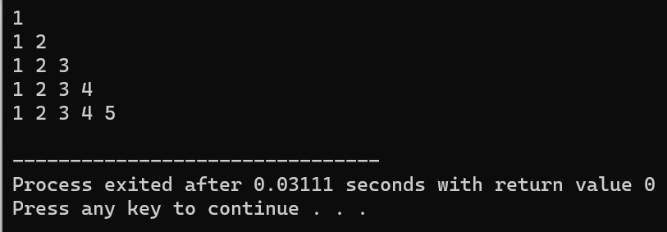

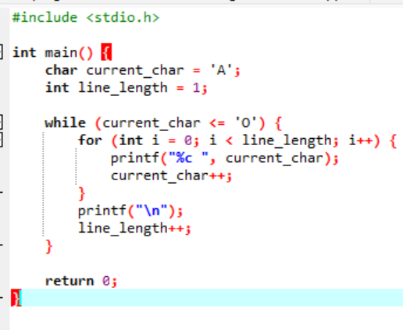

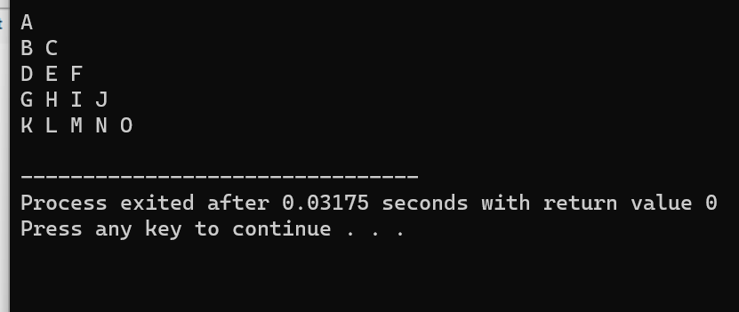

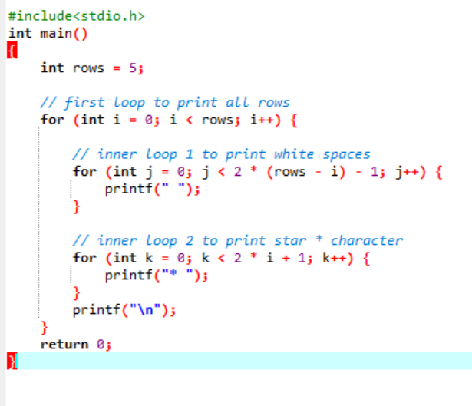 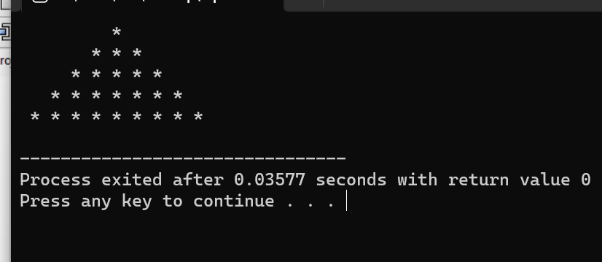

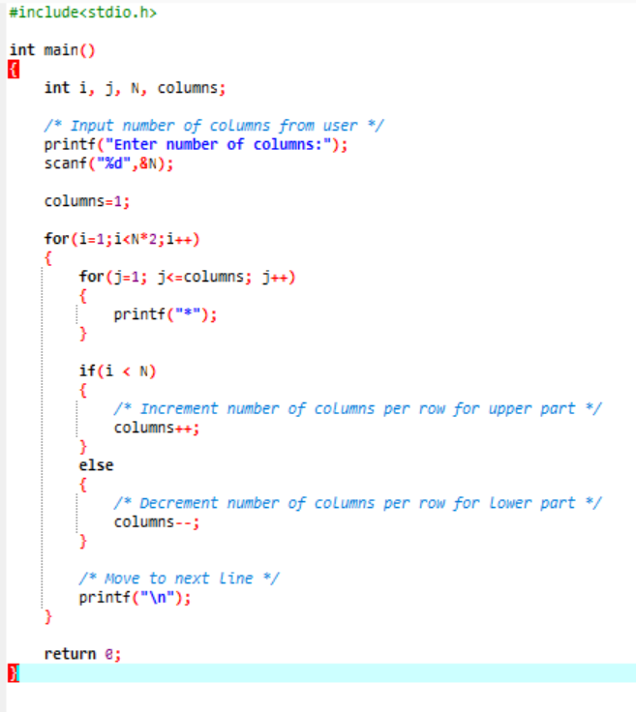 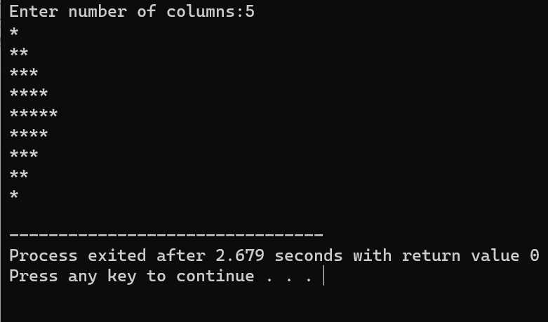

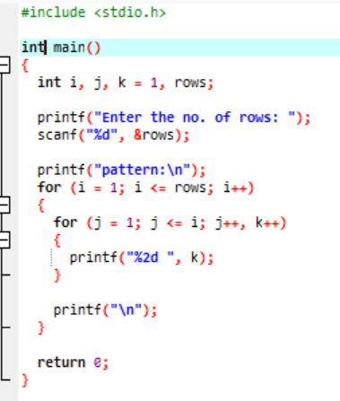

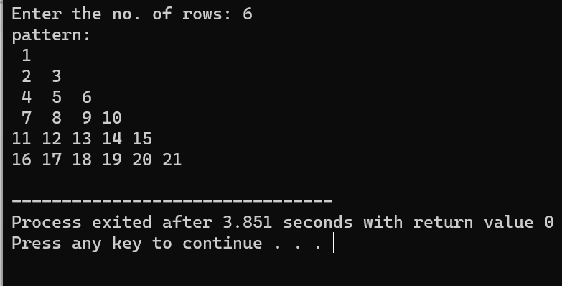

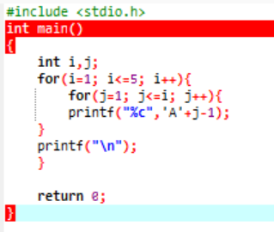 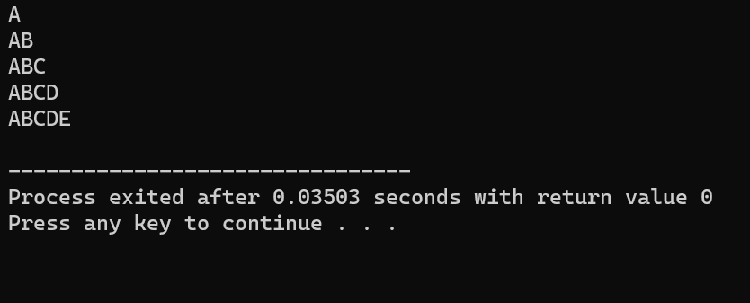

**MODULE: 3.3 (File Handling and Debugging)**

• Write a program to find out the max number from given array using function.

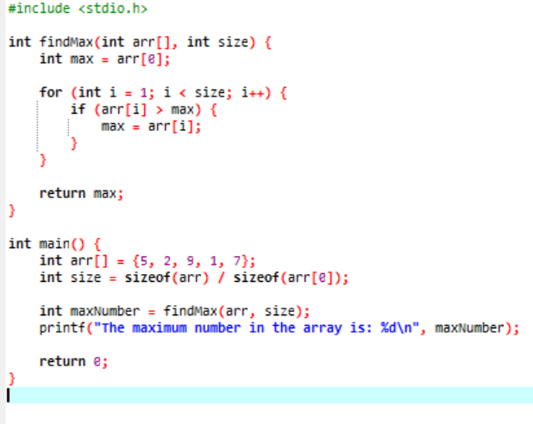 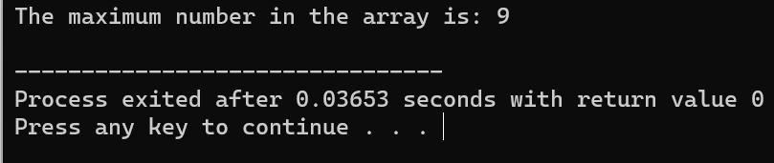

• WAP of Addition, Subtraction, Multiplication and Division using Switch case.(Must Be Menu Driven)

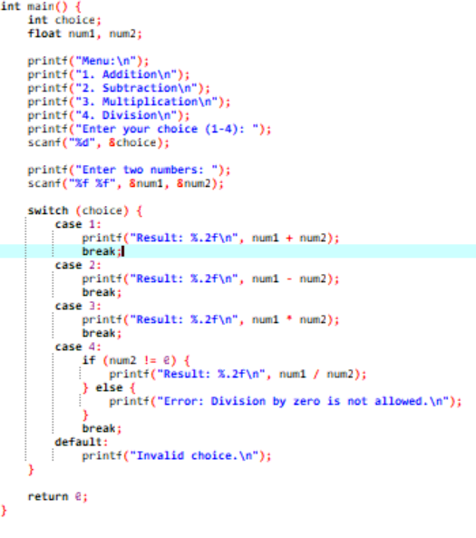 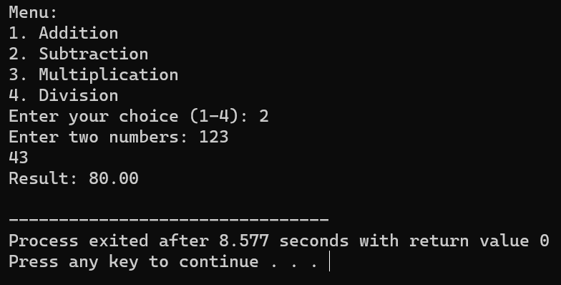

• WAP to find reverse of string using recursion

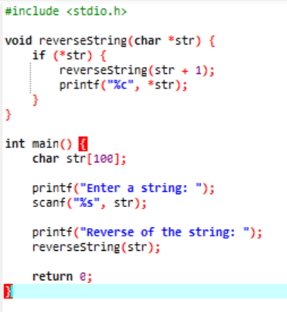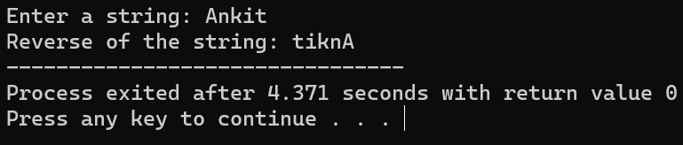

WAP to find factorial using recursion.

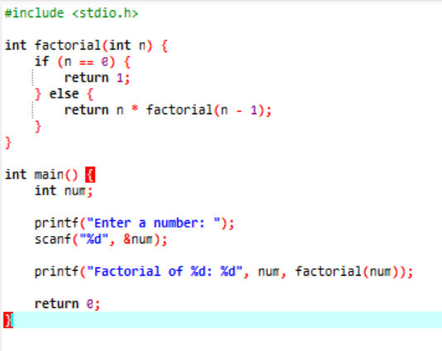

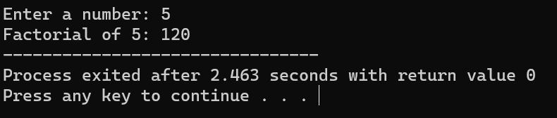

WAP to take two Array input from user and sort them in ascending or

descending order as per user’s choice.

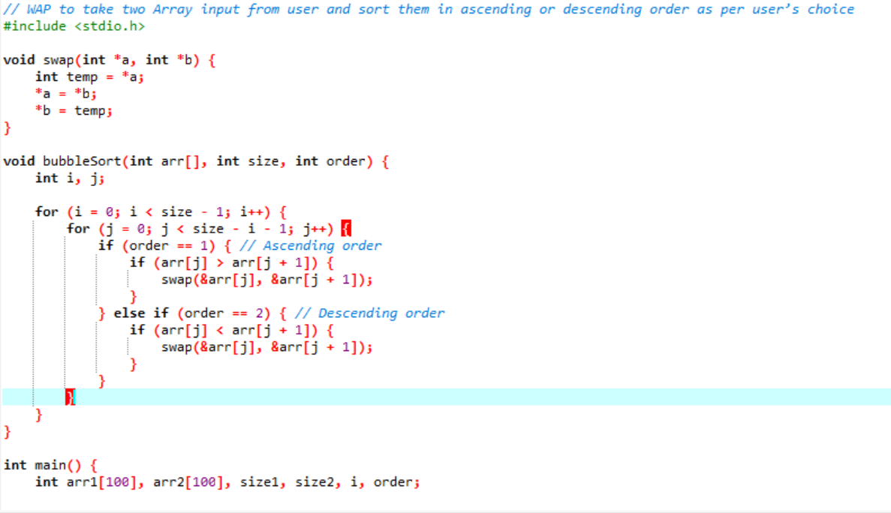

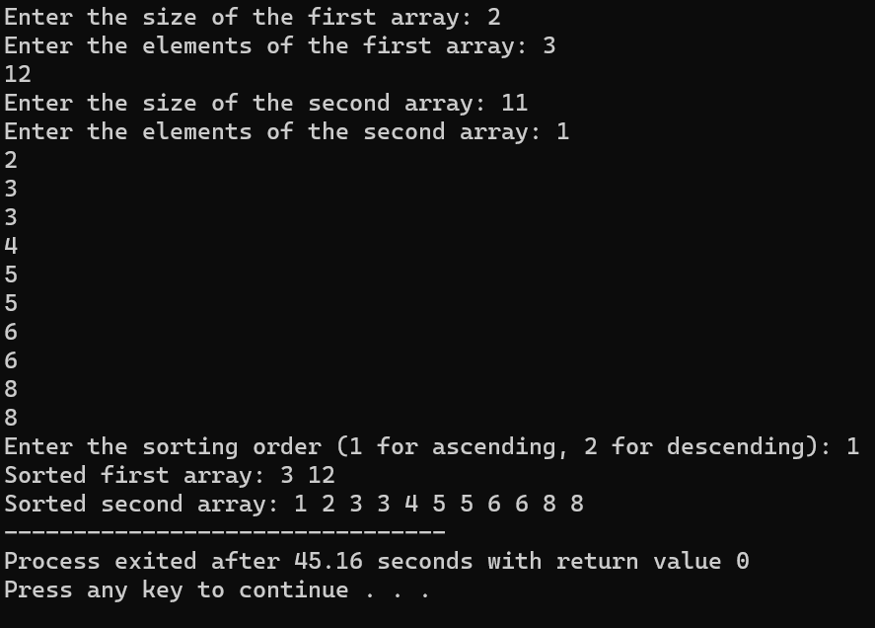

WAP to make addition, Subtraction and multiplication of two matrix using

2-D Array

**Addition:**

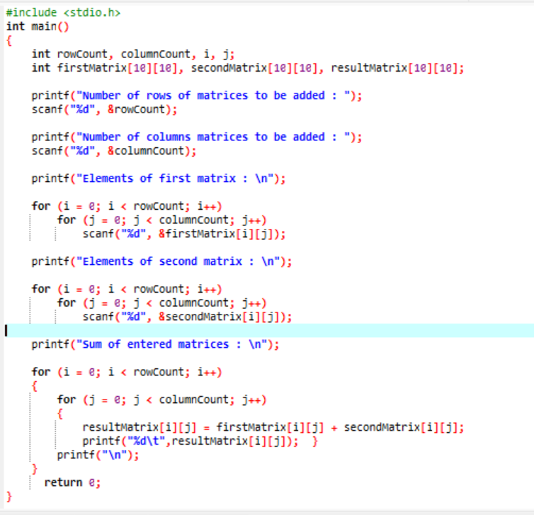 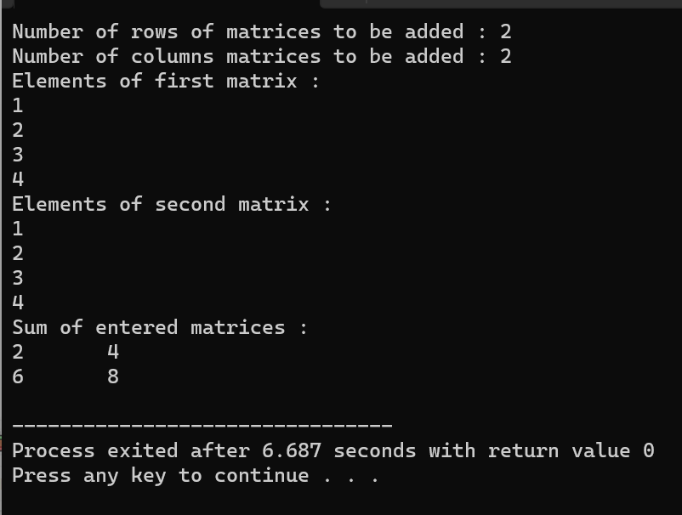

**Substraction:**

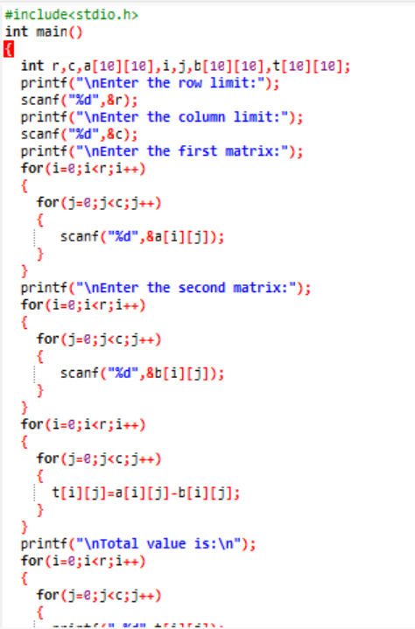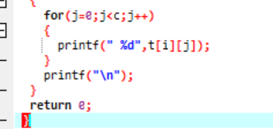

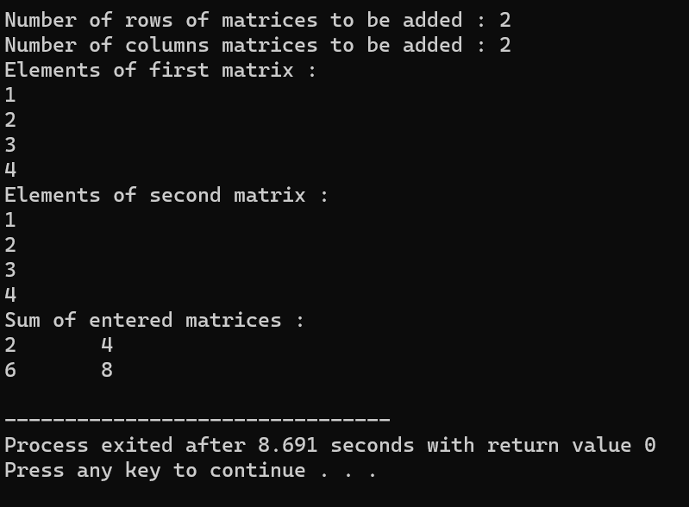

**MULTIPLICATION:**

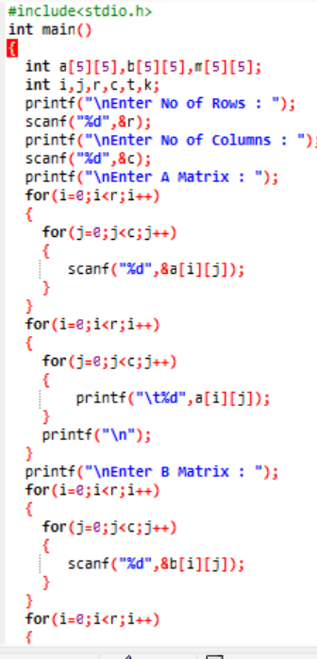 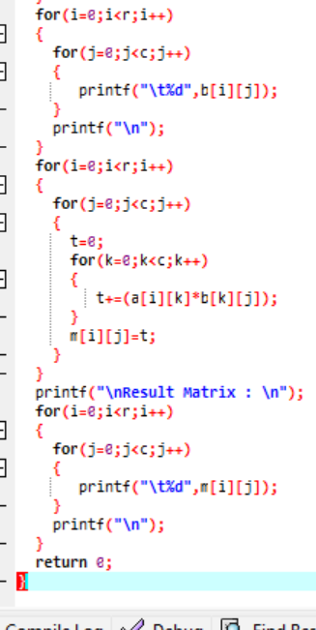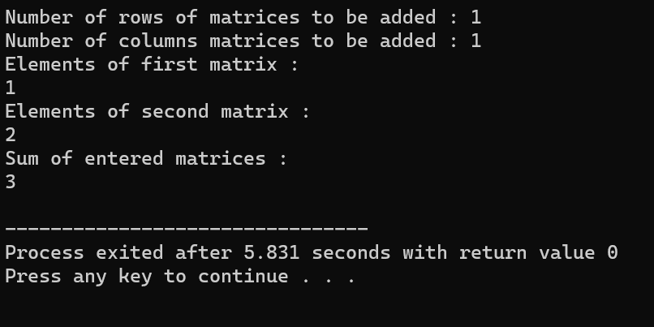

WAP Find out length of string without using inbuilt function

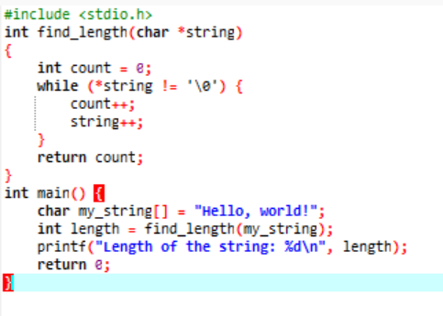

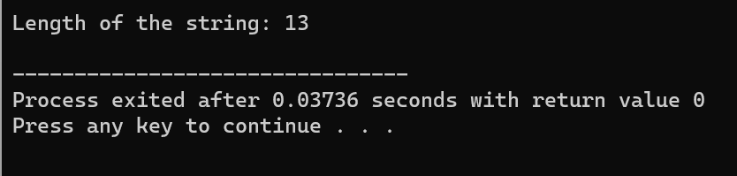

WAP to reverse a string and check that the string is palindrome or not.

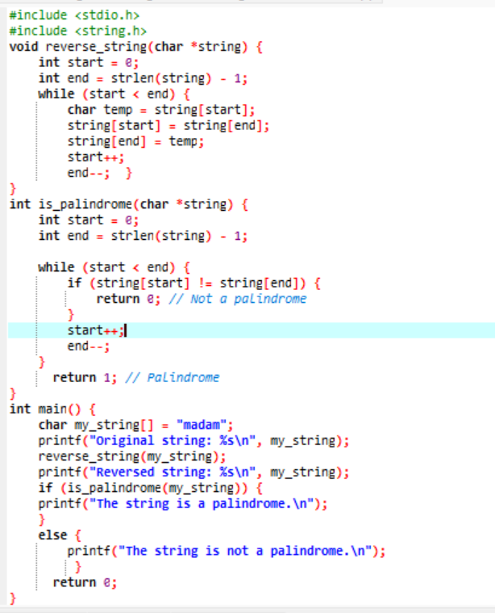 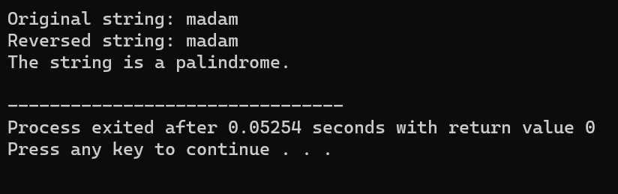

Write a program of structure employee that provides the following

information -print and display empno, empname, address and age.

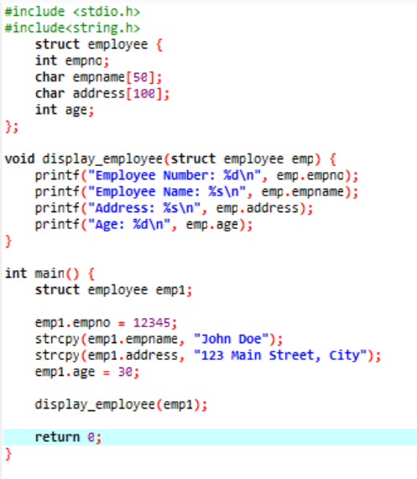

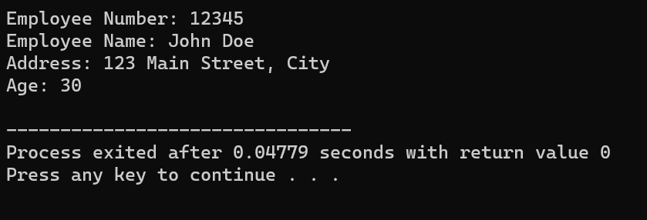

• WAP to show difference between Structure and Union.

